**Application Menu screen shot**

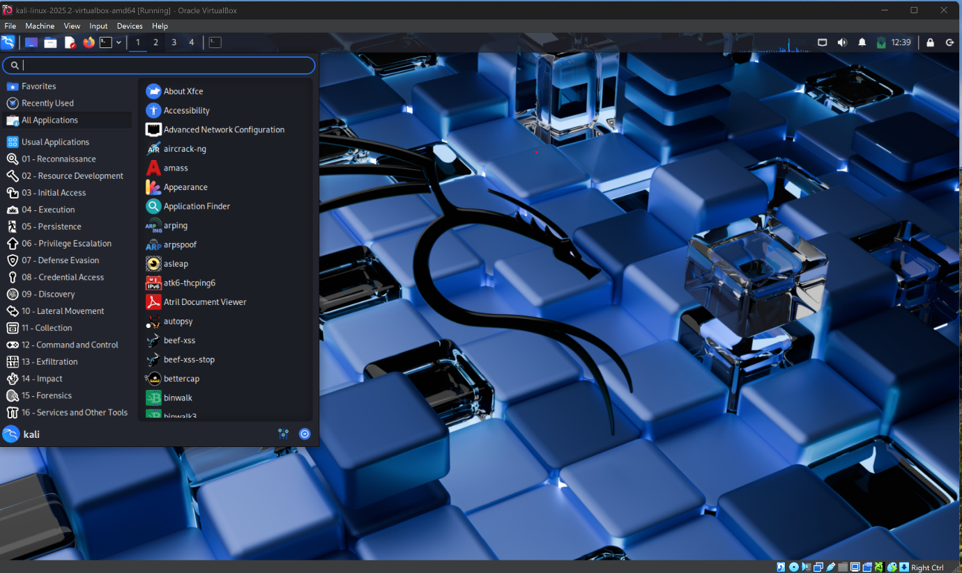

5 Tools from the Applications

1. Aircrack-ng
2. Amass
3. Application finder
4. Bettercap
5. Bully

**Aircrack-ng**

**Purpose:** Used to crack WEP and WPA/WPA2-PSK Wi-Fi passwords.

**Working**: It captures packets from a wireless network and performs cryptographic attack to recover the encryption key. The suit includes tools for monitoring, attacking, testing and cracking Wi-Fi networks.

**Amass**

**Purpose**: used for network mapping and reconnaissance

**Woking:** It gathers subdomains, IP addresses, and related metadata using passive, active, and brute-force techniques, helping identifying the external attack surface of targets.

**Application Finder**

**Purpose**: Helps users find and launch installed application easily.

**Working**: It scans the system for installed programs and provides a search-based interface to quickly access them, improving desktops usability and efficiency.

**Bettercap**

**Purpose**: A network attack and monitoring tool.

**Working**: It performs man-in-the-middle attacks, packet sniffing, spoofing, and traffic manipulation on wired or wireless network, often used for testing network security.

**Bully**

**Purpose**: Exploits WPS vulnerability to retrieve Wi-Fi passwords.

**Working**: It uses a brute-force method to guess the WPS PIN of a wireless router and, once successful, extracts the WPA/WPA2 key, bypassing standard authentication.